1.Which zener diode has the least temperature coefficient?
(a) 0v (b) 5.1v (c) 7.5v (d) 10v
2.Stamping of induction motor are used to prevent => eddy current losses
3.Ferrite materials are used to reduce => hysteresis losses
4.Holding current is less than Latching current
5.K-map is used to => minimize logical expression
6.The shape of cell in mobile/cellular phone => hexagonal
7.Total memory space of a 16-bit microprocessor => 64KB
8.If the supply is 50Hz in case of induction motor find the output frequency if load is halved.
9.Find a stable system below if the characteristic equn. Is
(a) -s+1 (b) -s3+s2+1 (c) s-1
10.The gear which gives lowest speed for moving => worm & worm wheel
11.Machine gives highest starting torque below
(a) Sync. Motor (b) series motor (c) induction motor (d) stepper motor
12.Transformer can't be used for
(a) Freq. changing (b) impedance matching (c) current transformation
13.What is the voltage drop across a RED LED?
(a) 0 (b) 0.3 (c) 0.7 (d) 1
14.Intel 8279 is used as => keyboard controller
15.A 3 1/2 digit storage meter can store
(a) 1999 (b) 2999 (c) 4999 (d) 9999
16.A D.C. Shunt motor runs at 2000 rpm and emf is v. If speed is 2800 rpm what will be the emf?
17.A D.C. Shunt motor runs at 2000 rpm at a certain voltage. If the input voltage is halved what will be the speed?
18.In 8085 AC flag is used for which operation => BCD
19.Quick return mechanism isn't found in
(a) Shaper (b) planer (c) slotter (d) broaching machine
20.Questions on Pulse width modulation not suitable for frequency change modulation
21.Questions on Multiplexing of microprocessor => reduction of IC pins
22.RMS voltage can be best measured with => sinusoidal or periodic
23.Jigs and fixtures are used for => holding job and guiding tool
24.E-mail / Fax goes through => telephone line
25. % CARBON in die steel => 1
26.Odd man out
JAVA,LAN,C++
27.300 + => unilateral tolerance
28.Find the o/p when ckt. Is closed instantaneously 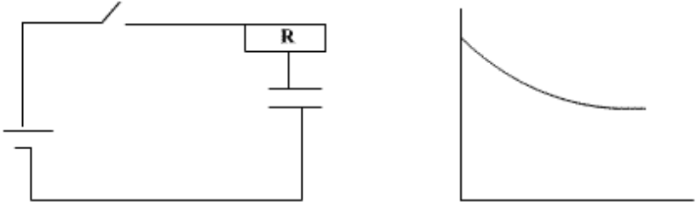
29.Find the o/p
